18th January 2020 GCH, LONDON,
The Day of Remembrance of our Beloved Pita Shriji Prajapita Brahma
‘Living Towers’
REPORT
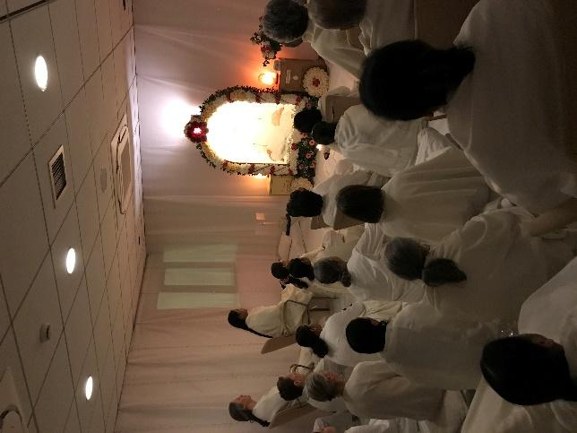
Yoga started early in Baba’s room at Global Cooperation House, with Baba’s picture beautifully adorned with flowers, and then Amrit Vela moved to the Auditorium, conducted by Brother Balwant, Sister Jayanti and Sister Maureen, with over 400 present. Toli, blessings and the reflective journal booklet for the day, ‘Living Towers’, were all shared.
Combined Murli was read by Sister Jayanti, in a packed auditorium of 600 souls, with all the morning classes coming together, Hindi, Tamil and English. After Murli, a beautiful slide show of the scenes from Madhuban on 18th January morning were shown, highlighting once again the extraordinary flower creations at each of the 4 pilgrimage places: Baba’s Room, History Hall, Baba’s Hut and The Tower of Peace. There was also a short video of Dadi Janki and the gathering at the Tower of Peace, as she toured the four places.
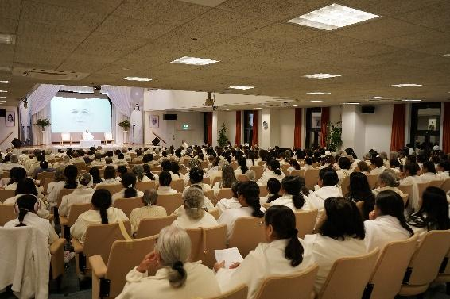
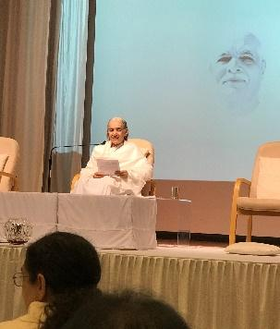
Before Bhog was offered and then Sister Jayanti shared:
If we pay attention as Brahma Baba did, we will get inspirations. In the Murlis recently Brahma Baba has been sharing how he made such intense effort to become soul conscious - day and night. When Baba looked at a soul and he would only have thoughts of how that one could move forward and come closer to Baba. He has now been in the avyakt angelic form for 51 years doing unlimited world service. He became avyakt in 33 years. How far have we come and how far have we to go?
Sister Jaymini
Baba became avyakt in 33 yrs. I am over 40 yrs! What vision do I hold? Baba told Dadi Janki that perfect Brahma Baba was in the subtle region and that ‘this’ Baba would become that. We all have our complete and perfect stage in the subtle region, so we need to invoke this. Shiv Baba has given us the aim - how far or close am I to this. When the days of exams come close, it is time to check where are the gaps. As our intellect comes closer to Baba, we receive touchings. This 18th January seems like an alarm bell and that there is now not much time left. So whatever time there is, be lost in love and ensure the intellect is not going elsewhere.
Sister Jasu
I toured around the House this morning and was reminded that ‘success is my birthright’. Brahma Baba never let anything be an obstacle and he would go beyond easily. We mustn’t stop anywhere and just keep moving forward. Baba is so patient in the subtle regions and is always there to move us forward. Seeing this, I feel I have to move forward intensely.
There then followed bhog, which had been prepared from 2am this morning by the kitchen team.
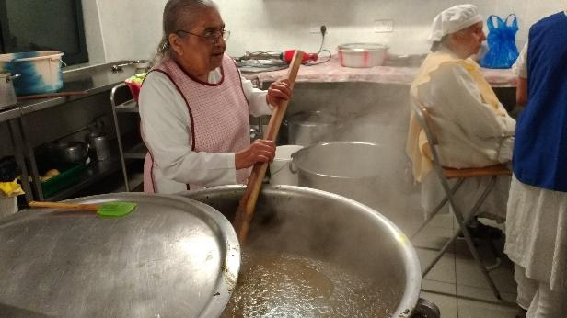

An hour followed to explore the rooms, all encouraging new reflections on becoming towers of peace: The Conference Hall encouraged contemplation on The Tower of KNOWLEDGE (A life size replica of the Tower was in place) and how we investigate and churn, experience,imbibe and share the Murli.
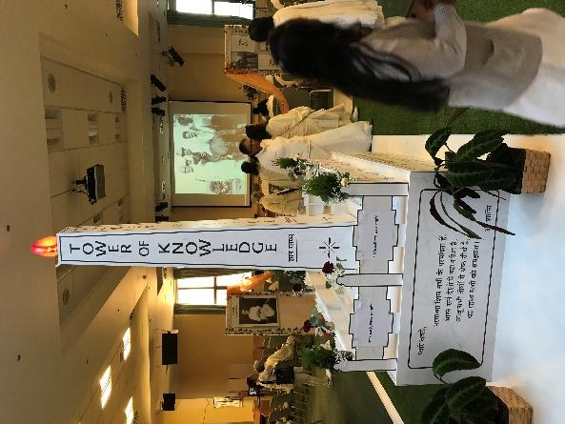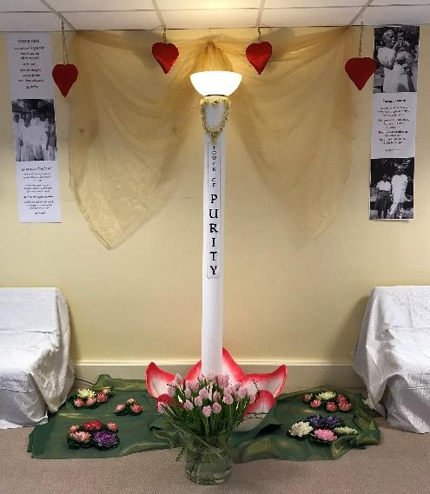
Children’s Room focused on The Tower of PURITY and invited us to write a purity pledge for 2020 on a large picture of lotus petals and in the muddy water below to see what we would like to let go of.
In the Seminar Room was The Tower of MIGHT- a place to burn our weaknesses and give sakaash to the world.A ‘yagya’ was set up where we could contemplate: ‘what root of unhappiness am I determined to burn today?’. We were then invited o reflect on: ‘what is the one missing piece in the jigsaw of my perfect form that will make the picture complete?’.
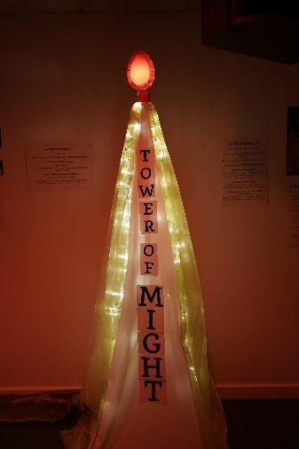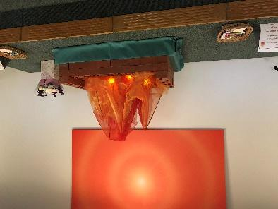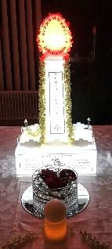
In Diamond House Foyer’ where The Tower of PEACE was the focus, there was a chance to sit around the tower and reflect on ‘Peace is my original religion’ and also ask ourselves: ‘what special experience of peace is Baba giving me today?’ was held
Sister Maureen welcomed everyone back at 10.15am: ‘One line I loved this morning was: leave the past behind and keep moving forward and we are working for establishment. As we aim to be those living towers with Baba, we are in that task and doing it’…..This is a day of love and power and it is beautiful to be together in a big family to enjoy this.
The recently created ‘Memorial of an Angel’ video transported us all to the real The Tower of Peace and many, including seniors, shared their personal experiences of The Tower. The variety of experiences shared was beautiful and all about the extraordinary power that this most sacred place on earth holds. You can see the video here: https://youtu.be/31gTZhaXtQE
Sister Santosh of Russia shared the history of the sports ground before it became Brahma Baba’s memorial place and how this then became the cremation ground and then the memorial ‘to teach people about who Brahma Baba was and his lasting legacy for mankind’. She explained how it was designed and built and how the whole space was developed. Something was needed that would match his personality of royalty and dignity. His life depicted as a Tower. Sister Jayanti also shared: ‘When I went back and saw the Tower, before the marble floor etc….I thought it was absolutely the right memorial for Baba. He never wanted his face on anything…or to be filmed…a statue would not have been appropriate…..this was perfect for our beloved Baba
A few quotes from personal sharings from around the world:
- There is something alive here…. It is not a memorial of someone who is’ dead’. It is like the presence is still palpable.
- Everytime I go there it has a feeling of coming home and feeling at ease.
- When I saw the Tower of Peace I felt like Baba was standing there with his arms open welcoming us.
- Every time I look at it Baba comes alive. This is the land that Brahma Baba walked for so many years and the land in which Mama and Baba played games.
- The place where we would play badminton with Baba - those memories come flooding back, as well as his final ceremony. This was very quiet and sacred and also emotional of course.
- The Tower of Peace reminds us of his complete life. He surrendered everything:property and prosperity and became a trustee and it became the highest pilgrimage place of all..
- Understanding why it is a pilgrimage place…..his energy is there.
- Each step I took took me into a deeper layer of inner silence and I realized this is a special place. This is a memorable place.
- It uplifts and inspires and makes us feel complete and as if anything is possible.
- There is a kind of silence around it…..walking into solid silence. It is an extraordinary energetic place As people think of God and Brahma Baba and what he did and this leaves an imprint.
- In Madhuban the Tower of Peace is a portal…to go beyond all the things of this physical world. I have had some of my best touchings there.
- I first experienced lightness here.
- When I was experiencing challenges I went there every day…and the insight I got was to use the Murli to resolve any issues I had.
- We used to have World Peace Hour at the Tower of Peace during the Summer...
- On the 18th January we can feel the significance and memory of that time and how the loss of his physical presence was a real challenge.
- On the 18th January I feel the greatness of the number one human soul Brahma Baba. We stand in silence of the Tower of Peace and read and remember what Brahma Baba taught us in these messages.
- It is part of my routine in Pandav Bhavan. I can have an informal chit chat with Baba. That is very special to me and feels very intimate
- We feel that solitude and connection with Baba.
- I feel so still inside…when I sit with that great soul and feel His journey and the stage he reached. This is where the number one human soul became a complete angel because of his deep love for One.
- The Tower of Peace also makes me say: Yes, I can follow Him.
- I often get a different fragrance from Baba on each side.
- There is a sense that both Shiv Baba and Brahma Baba are calling us to leave the physical dimension behind and be pulled into the subtle dimension with them. This light calling us back home to Paramdhan…a powerful reminder from physical to subtle and then the pull of Shiv Baba to our Sweet Home, to the Land of Silence.
- The evening meditation has its own atmosphere and stillness that comes at that time.
- It is the memorial of the soul who conquered all matter and became a full angel.
- Now when I come to the Tower of Peace and I feel the deep silence and the way Baba invoking the children. There is a deep sense of love and invocation of Baba drawing us in and wanting us to fulfil that too. It is very uplifting…..
- We now recreate the Tower of Peace in other centres so everyone can feel the vibrations of Madhuban.
- Gratitude and wonder of this highest pilgrimage place. From this place we can send out vibrations of peace and serve the world ..
Clarke Peters and young kumari Shree shared:
- It is the eye of the vortex, the centre that is very still and peaceful. The peace here is when everything is still and the noise of the world stops. When we experiment with Baba and put him before us and and let Him guide us out of situations that are difficult, we feel His magic.
- When I am kind of confused it helps me become peaceful and connect with Baba strongly
- To get to each side of the Tower it as though you have to move through another: from Knowledge, Purity, Might to Peace.
Lucinda Drayton also shared her song ‘Here where You ay – ‘A love letter I wrote to Brahma Baba and my tribute to this beautiful place.’
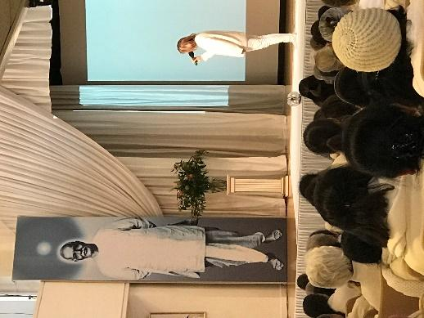

Sister Jyoti Wadhhani shared how ‘Sister Jayanti and myself were there at the tail end of Sakar Baba’s days’. When I stand at the Tower of Peace I can see those days and these days. In those days Brahma Baba worked so hard to give us all the happiness. With all the little things, such as toli. When He spoke the Murli he was very official and beautiful as we knew Shiv Baba had come in the body. She shared the simplicity and joy that they all enjoyed with Sakar Baba.
Sister Jayanti then noted ‘We have a special resource in Jyoti in London. She would spend more time than the Dadis with Brahma Baba and she had the practical father’s sustenance.
For me it is Brahma Baba’s life, the Tower. There were many beautiful experiences of those in the film. .Baba is the Tower of Peace. Being in front of Baba his drishti would carry us beyond. .Multiply the peace we experience saying ‘Om’ a thousand times and you get the experience of Baba, The Tower of Peace.
Every step along the way, Baba was demonstrating knowledge and the right way to be moving and doing everything - the way he would move, talk and eat and go on a tour of Pandav Bhavan. When we study him, we realise he never said anything that he hadn’t done himself. He gave so much love and kindness to each one. He was the embodiment of the Tower of Knowledge and also his life was The Tower of Might..Just imagine the power it took to start from nothing, surrender and face all the challenges of the community - it was an incredibly powerful thing he did. Then when Mama and Dada Vishwa Kishore had left, he played the role of mother, father, friend… he was one individual holding it all together. Baba was also the Tower of Purity, bringing together people from different backgrounds; he pulled them together and made them into one gathering. It is the foundation of Baba’s purity, his pure love for each one, that is still holding us together today. He handed that legacy to the Dadis and, as the Yagya grows, it is because of these roots, the power and the purity that Brahma Baba demonstrated in his life. The work that the Dadis have then done is to create a world wide family. We now have Brahma Baba in his angelic form and the teachings He and the Dadis have left us. Our purity and unity is the proof of the work that they have done.
.Sister Jayanti then encouraged everyone to take time to answer the questions in the reflective journal:‘It will help you do what you need to do to be an instrument to carry Baba’s legacy forward, so that soon we can reveal Baba to the world - the instrument for God to be able to bring everyone into the bond of love and purity’ You can download the booklet here: https://drive.google.com/file/d/0B9ncXF3WZN_1MzJla2ZpNEFaY3d3WnNEd3RZRGZkX3RrYmlV/view?usp=sharing
A new decade is a chance for something fresh to happen. The systems of the world are falling apart. That is clear. We are reinforcing these roots so that the tree that grows out of this lasts a few thousand years.To have peace, knowledge, might and purity in my life, so I can consolidate and be with Baba. So, take inspiration from Baba the Tower and also be inspired for yourself to be a Tower.
Bhog was then offered and Brahma Bhojan was shared with the whole gathering of over 700. There was then the live transmission of Baba’s murli of 18 January 2007 from Madhuban and an evening hour of Yoga closed the auspicious and powerful day.
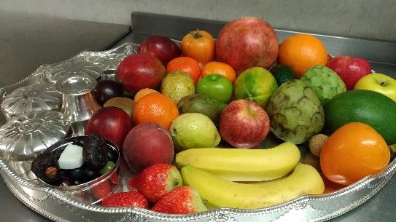

ENDS

