Women ‘Online’
“Can a soul conscious awareness support us in this digital age?”

In honour of International Women’s Day (IWD) 2023
Global Cooperation House, Sunday 12th March 2023, 2-5.30pm

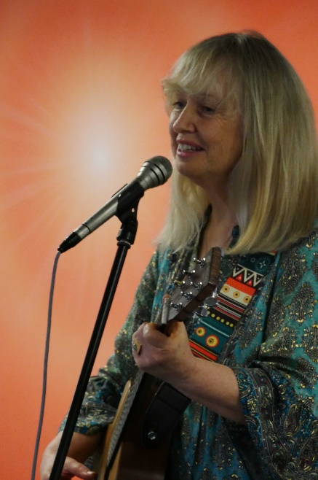
The United Nation’s Theme for 2023 was DigitALL: Innovation and technology for gender equality
Ann Malone, an internationally recognized singer and songwriter.

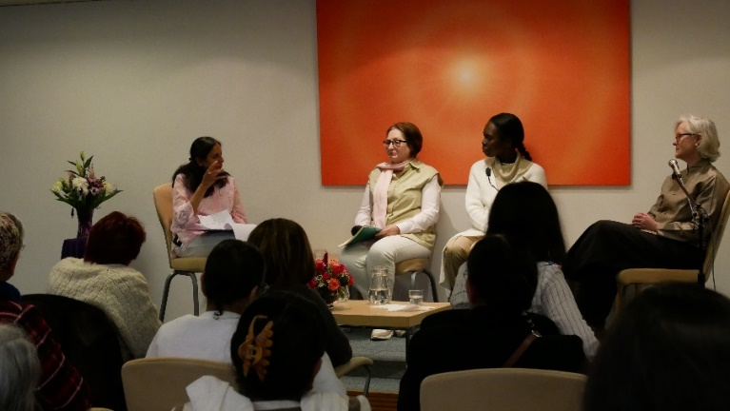
The expressive and informative afternoon conversation amongst the three panellists and moderator began with a series of slides showcasing women who have an influential and positive presence on the web. This was followed by Anne Malone singing and strumming on guitar to welcome everyone.
From right to left: Margarite O'Keeffe, Louise, Els, and Parul
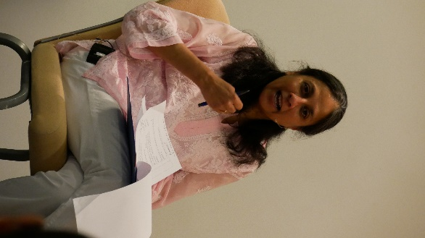
Parul Shaw, the Moderator for the afternoon, welcomed the panel of three speakers who came prepared to give their own views and understanding on the perspective of: “If and how a spiritual perspective and practice can help us make the most of being online without falling into its many traps”, and “how we can use it to influence and co-create a more beautiful world where women are treated with respect and dignity”. The three panellists were articulate and vibrant as they presented their perspective on the theme and each highlighted a different aspect, which included the many varied scenarios facing women today.
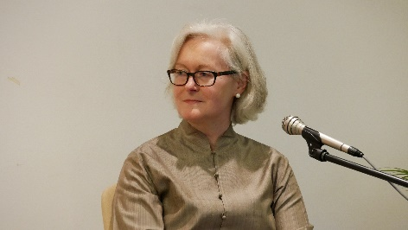
1st speaker – Margaret O’Keeffe: Her message, coming from an eclectic spiritual viewpoint, described how the digital media’s influence on us, impacts our online worldview and becomes an extension of the relationship we have with ourselves. She elaborated on the topic by looking at how the relationship between internal and external identity influences decisions; and that we can clarify this for ourselves by asking three questions: i) Who am I? ii) Why am I here? iii) What do I want to express? She emphasised how necessary it was, to not only ponder these questions but also, to ask, “who are we as human beings”; and “who are we becoming”? She admitted that the term “soul consciousness” was “a bit lofty” for her, but that she kept in touch with her inner state of wellbeing by stopping when she had to make key decisions, and asking herself, “Does this come out of fear or love?” If she feels derailed or not at ease, she takes time out before she responds. Regardless of the ups and downs, she actively seeks to remain neutral in terms of expectations or outcome. She has three values that adequately guide everything she does in business and she refers to them as the power of three: “Honesty, Compassion, and Creativity”.
Margaret O’Keeffe is the co-founder and Managing Director of Curious Leaders, a coaching consultancy that specialises in aligning internal and external identity at individual, team and organisational levels.

Parul Shaw is an IT Consultant and a Life Coach. She also helps with the activities of the Brahma Kumaris in London and the UK.

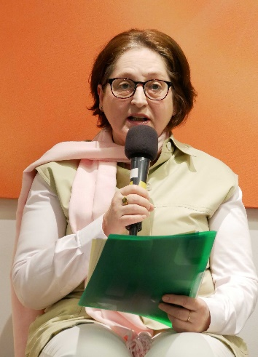
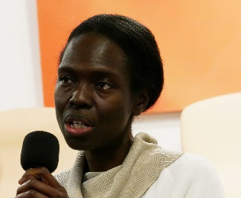
2nd speaker – Louise Richmond: Approached the topic using the ‘soul-centred’ awareness she maintains in life as a means to better manage ‘me’ through negative influences and distractions. She added that the world is constantly changing so much, that the whole aspect of self-identity plays an important role. Therefore, she felt it necessary to become more cognisant about herself and how she uses the Internet. She shared, that when invited to be part of the panel she asked herself the following multiple questions: “Do I actually need to change my attitude when using the Internet?” “What is it that I need protection from?” “What awareness does one need to have?” “How will a soul-conscious awareness help me when I am on social media such as Facebook, Instagram or on Amazon purchasing something online, etc.?” She stressed that she was looking forward to exploring these aspects with everyone.
Louis Richmond has been a student of Raja Yoga meditation since childhood. She has previously managed IT projects within the private sector and now works on bespoke projects with the government.
3rd speaker – Els Braeken: Sharing on the plight of women in this fast-paced digital world, Els brought to our attention, factual information and statistical facts, that the UK had recently published in their “International women and girls’ strategy 2023 to 2030” plans which were presented by the secretary of state to parliament. She communicated, that it listed an extensive campaign and programme aiming to attain gender equality by 2030. She recalls that even in England, not so long ago, women could not vote or study at a University, and many professions were not open to them, so even though we can say that there has been a lot of progress for women already, there is still a long way to go to gender equality. However, she added that with social media readily available, technology has greatly improved the quality of our lives: we can easily stay in touch with our families, friends and contacts; there is easy access to a lot of interesting and important information online; learning programmes are easily accessible and available; and so it is useful in our daily life. She then pointed out the downside to it all: cyber-attacks, identity theft, financial fraud, and especially for young women, the danger of dating sites, and romance scams specifically targeting women. Els subsequently shared that she was able to survive in an extremely fast-paced IT environment by having a regular practice of soul consciousness and spiritual practices which helped her stay focused with a clear mind and enabled her to recognise fake news and online dangers.
Els Braeken has been teaching and practising Raja Yoga meditation for many years. She graduated from the University of Antwerp (Belgium) with a degree in Socio-Educational Care. She now works for an IT Consultancy Company in London.

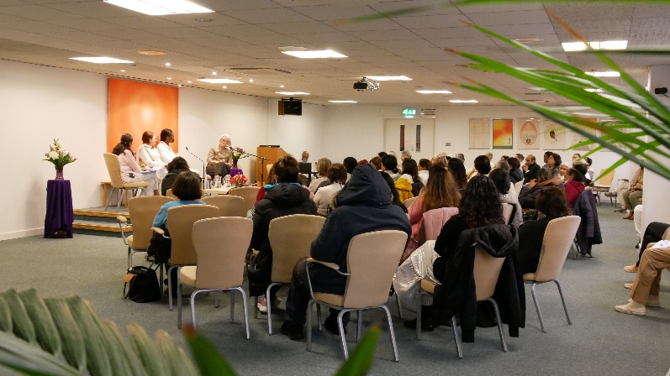
After having heard the views and thoughts on the topic from each of the speakers, the moderator invited the audience to share their thoughts on the topic or to ask questions. This part of the session also included the moderator requesting the speakers to dialogue on specific words they had used in sharing, such as ‘identity’, ‘soul-consciousness’, and ‘traffic control’; and specifically, to share what soul-consciousness meant to them. Answers given were: a) understanding myself and experiencing myself to be a very positive, pure, powerful and peaceful being; b) not being attached to external roles, i.e. not losing the awareness of the inner nature of the soul whilst interacting with everyone and everything; c) not reacting if the inner state of being became influenced by fear or anger, but rather to respond with kindness.
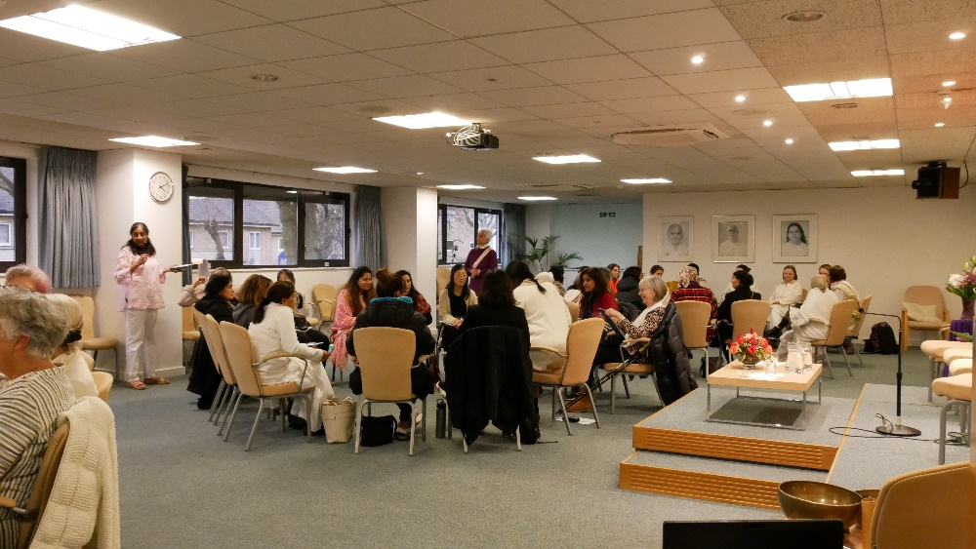
After the tea break, the 60 women who attended were guided into three groups and were welcomed back from the break by the beautiful sound of Ukrainian bells played by Ann Malone that refreshed and transformed the atmosphere in the room into a lovely cloud of lightness, peace, love, and joy that uplifted all who were present.
Ann Malone playing Ukrainian Bells
In the groups, answers to the following questions were discussed:
- What kind of relationship do you have with digital media today and how does this relate to your personal identity? Facilitated by Margaret O’Keeffe
- What one change could you make in your life to help your awareness be more ‘soul-centred’? Facilitated by Louise Richmond.
- How does having a sense of purpose contribute to being un-influenced from the negativity on the web? Facilitated by Els Braeken
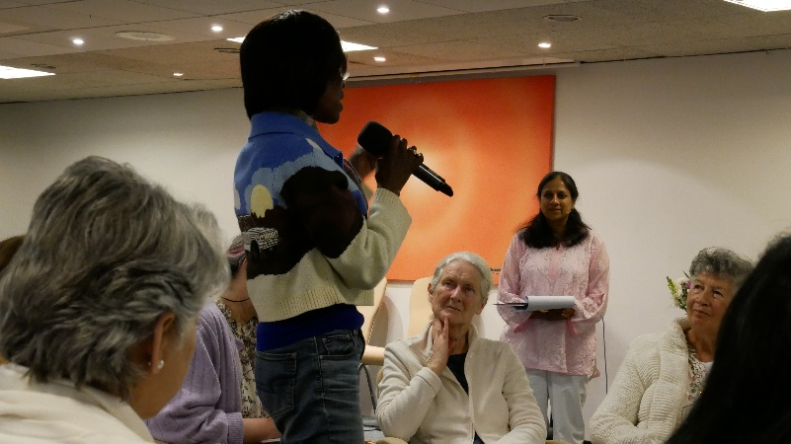
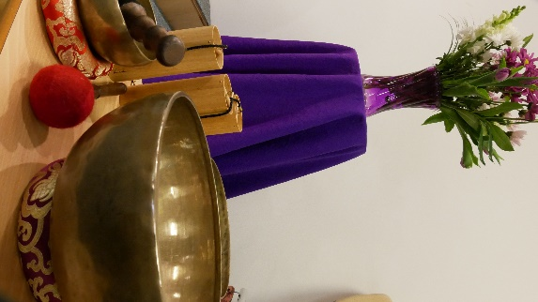
When everyone reconvened, a representative from each group enthusiastically shared the learning and outcome from their respective group. The afternoon session culminated with the facilitators sharing their observations on the discussions from their respective group.
The programme finished with a meditation commentary led by Cathy Piccione and accompanied by Ann Malone playing the sound bowls. As they departed, everyone received a traditional sweet (toli) upon leaving.

