Go High - How to Be Above It All
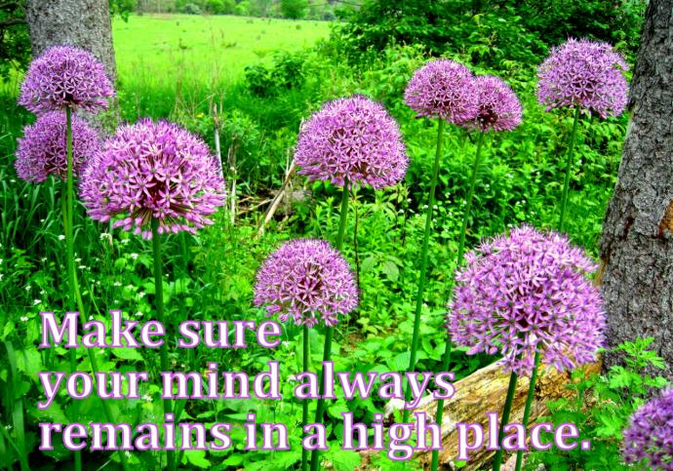
What often upsets us most are the words and actions of others. There is a tendency to be carried away in a storm of negative thoughts which are of no use and lead us further from the solution. Learn to live and look at everything as a detached observer, and situations will not affect you. When you find yourself feeling upset by what someone is saying or doing, separate yourself from the situation. Remind yourself that everyone’s part is unique, and no two parts are the same. To acquire spiritual power, go high to connect to God’s light. Throughout the day ‘listen in” and consciously choose the quality of your thoughts; accentuate the positive, eliminate the negative and throw away the waste. As is my thinking so are my actions and experiences. Focusing on even one positive thought gives us the power to go high and to maintain stability even in the most difficult circumstances.
Michelle Obama* explains the method of detachment she uses to confront these moral challenges:
“Operating with integrity matters..and will matter forever… “We need to keep trying to go high. Going high is like drawing a line in the sand, a boundary we make visible and then consider - which side of this do I want to be on? It’s a reminder to pause and be thoughtful. Going high is something you do rather than merely feel. It’s about how to ‘fight’, how we go about trying to solve the problems we encounter and how we sustain ourselves long enough to be effective rather than burn out. ….My power lay in whatever I could manage to do with that hurt and rage and where I could take it…..”
“For me, going high usually involves taking a pause before I react. It is a form of self-control, a line laid between our best and worst impulses. Going high is about…figuring out how to respond with a clear voice to whatever is shallow and corrosive around you. It’s what happens when you take a reaction and mature it into a response…. in the direction of a larger solution.”
“Be careful about letting emotions guide you. Rage can be a dirty windshield. Hurt is like a broken steering wheel. Disappointment will only ride, sulking and unhelpful, in the back seat. If you don’t do something constructive with them, they’ll take you straight into a ditch.”
To uplift someone, ‘go high’. Remain detached and also loving. Good feelings for others are like ointments that heal wounds and re-establish friendships and relationships. When we detach and go beyond attachments, we gain an inner clarity and concern and have an even greater love and regard for others. When we ‘go high’ and give deep spiritual love to someone, it touches their hearts and they don’t forget.
*TIME Magazine Dec 5/Dec 12, 2022, p74, Room for Reason and Rage
Contact: Yvonne Chirya Risely bkchirya@gmail.com chirya.risely@peacevillageretreat.org, PV Bookshop link: https://www.peacevillageretreat.org/all-books.html

