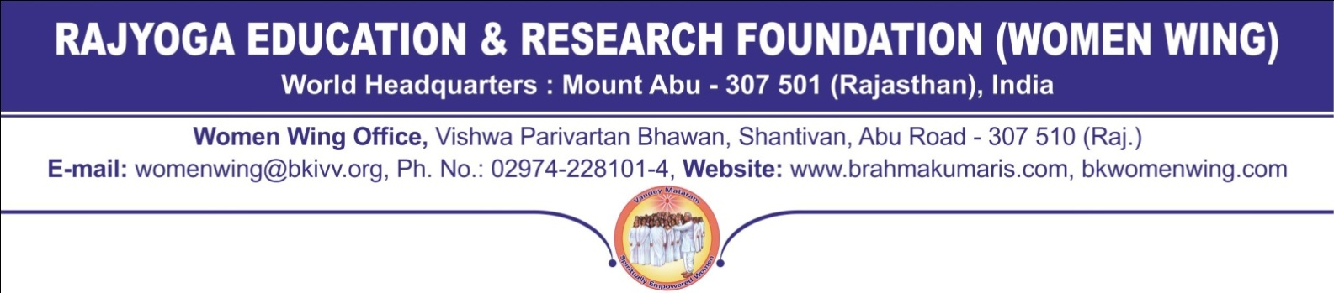
CORDIAL INVITATION FOR CONFERENCE -CUM -MEDITATION RETREAT
FROM 19.07.2019 TO 23.07.2019 , GYAN SAROVAR,MOUNT ABU (RAJASTHAN)

Dear Spiritual Sister

Please accept greetings of peace and love,

I heartily extend a very cordial invitation to you for Conference-cum-Meditation Retreat on “Happy Woman, Happy Family” to be held at our GyanSarovar Complex Mount(Rajasthan) From 19th July, 2019 to 23rd July2019 .

We are all aware that women play a vital role in our family and social life.Though many organizations and social movements are talking of women empowerment in today’s life but the positions of women in society is not that strong&powerful.

This Conference-cum-Meditation Retreat will give you an opportunity to experience the meaning and nature of the spiritual dimension of life and the importance of inner powers in life.

You will experience how to connect more deeply with your true nature and the eternal source of light and might. The Conference-cum-Meditation Retreat will help to enrich your life with inner power, value and wisdom through interaction, positive thinking, right habits and Rajyoga Meditation.

It will be a rare opportunity to know the contribution of this global institution towards moral,spiritual and rajyoga education for creating a better society. Our Women Wing is very happy to invite you to this unique Conference.

I hope you would be a part of this select gathering of women from all over India from different disciplines at Mount Abu.

In the Service of Humanity,
Yours Divine Sister,

(B.K.Chakradhari)
Chairperson, Women’s Wing

