BK Ecological Retreat for Europe & the Middle East
Casa Sangam 5 to 9 June 2014
Now is the time
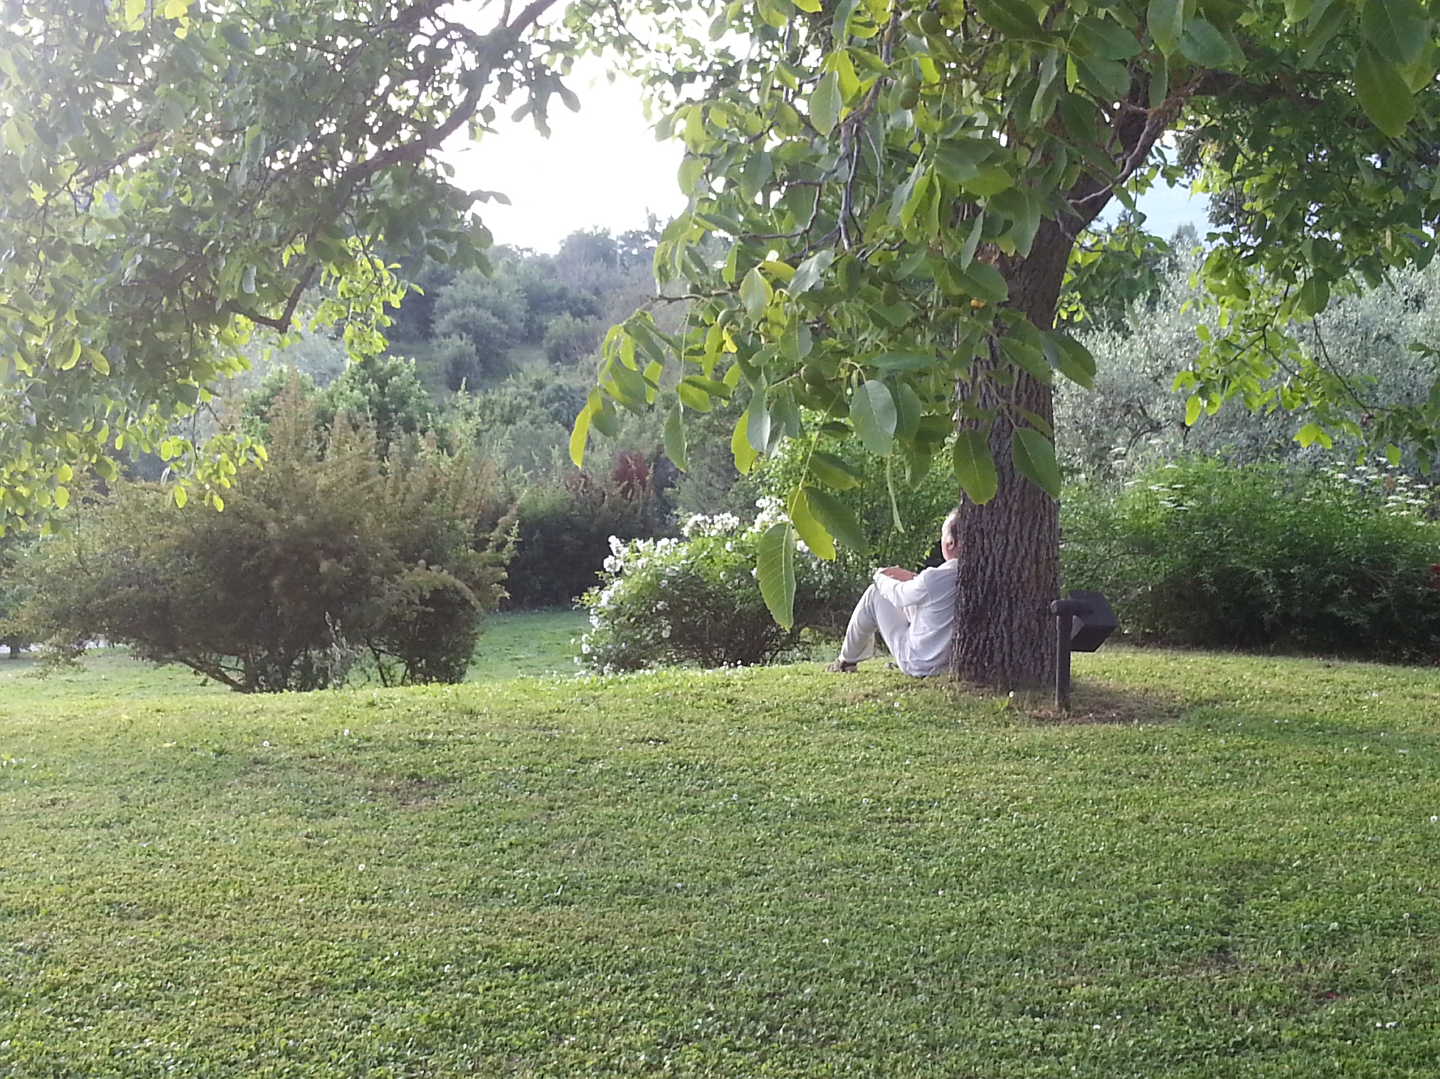
On the Thursday 5th June all the participants to the retreat arrived and were welcome to Casa Sangam . Participants discussed in which way they had contributed towards sustainable lifestyle in their personal lives . And Afterwards they talked about hat motivated them to come.
On the Friday morning as well as during the other days of the retreat after breakfast they went for a meditative walk to serve the elements- air, fire, earth, water, ether.
In the morning session, François Becher shared a presentation. Hhis presentation was on matter, money & production – an overview of how human beings live, relate and vibrate in the world. Some key points:
The environment is not only green – it’s like a rainbow (the white of the ice caps, the blue of the oceans, the pink of the people, the black of oil, the green of the forests…) Population: from 3 Bln in 1969 to 7 Bln now, in one generation. New souls have no sense of “history”, the come down and enjoy life on Earth – mostly through consumption. The Crisis created by us human beings, starting from WW2 onwards – we are now predating Ecology. Five areas are worth exploring: Earth, history, money, growth, spiritual approach

The earth is a living organism with different organs, just like a body with sea, ice caps, volcanoes, mountains, winds etc. There is a need for a natural, organic balance, the sustainability of life and death

In its history the human beings went through three phases:
The magic phase, before Galileo where everything one does is for the upcoming generation – Earth is then sacred, it is a gift from God. Humanity then went Through the machine phase with the exploitation of Earth and then a systemic phase
So these phases also correspond to four levels: Harmony – respect, love, divorce – selfishness, greed, lack of awareness, lifestyle – man is predator, Entropy – Exponential curve of population.
Spiritual approach:
The current scenario is, on the other hand, perfectly understandable from a spiritual perspective: the drama is accurate, allowing billions od souls (the last wave(s), probably) to descend on Earth and enjoy their moment of happiness. Gandhi: “There is enough for human need, but not for human greed”. Gandhi: “Simple living, high thinking:
Gandhi: “Be the change that you want to see”
In the afternoon, Giorgio took us to visit the farm
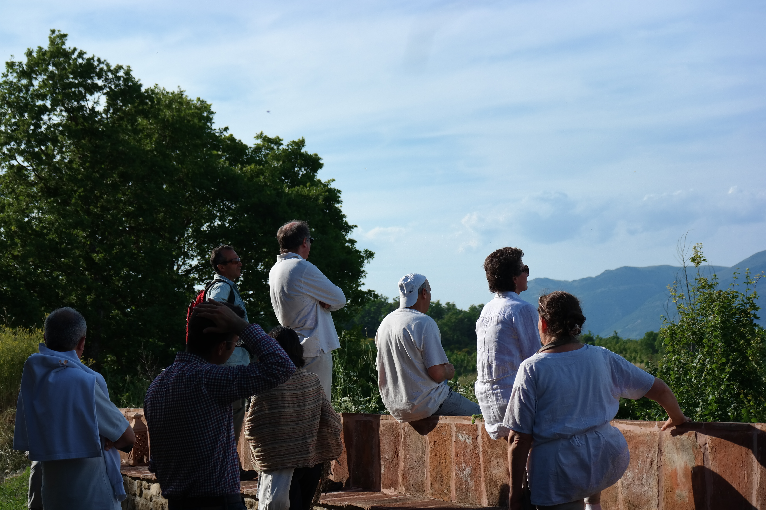
We visited the farm and had a good meditation from the walls of Mirabella, the up part of the property whre Piero has his residence.
In the evening we had an informal Conversation in which the participants all shared what they are doing in the field of environment and sustainability.
On the Saturday Valériane ran a workshop on sustainability where she ask the participants to reflect and share around these 5 questions:
Why is sustainability important for you? What specifically, in sustainability, is important for you? How would you explain it to a six-year old kid? Is there a relationship between Gyan and sustainability, and if so which parts of Gyan are important sustainability-wise?What does Baba want me to do (for myself, for the people of the world, for nature)?
She then presented by a drawing how the Knowledge of the Brahma Kumaris is conducive to a very unique way of understanding sustainability, taking its roots in a way of life that is completely conducive to sustainability by giving us the aim of constant connection with the divine and achieve total purity is allowing us to contribute to the creation of a future sustainable world.

In the afternoon Giorgio conducted a session on healthy food. Some of the points that were shared or recommended to study fearther:
- The China Study – book
- Milk and dairy are “the greatest killer”
- “Raw till 4”
- Fat is another “great killer”
- 80/10/10 – book: 80% carbohydrates, 10% fats, 10% proteins
- Carbohydrates are not only grains, cereals, but also fruit and vegetables
In the evening we had a get together where Valeriane explained the work of Brahma Kumaris at the UN in the Climate Change context as well as in Geneva.
On the Sunday 8th June, n the morning we explored How would the participants want to engage in this work. Through group reflection: How best to communicate the link between spirituality and the environment to BKs and others? Small group discussion
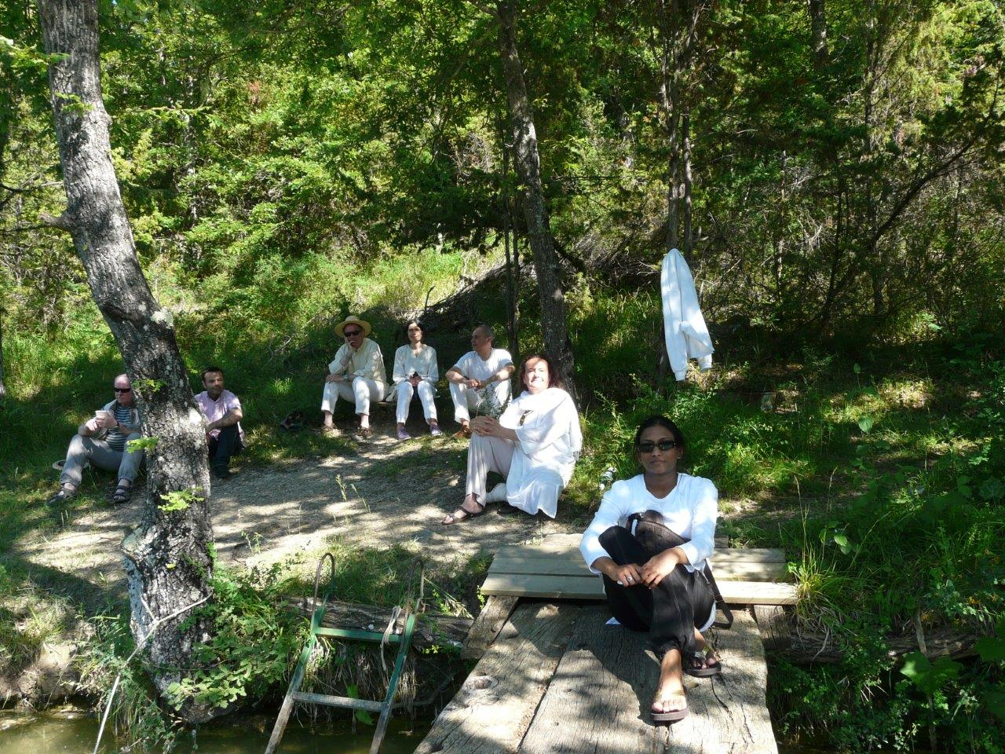
Walk to the lake with the last meditations for the service of the elements.
In the evening, there were feedbacks and the sharing of experiences:
People shared how they enjoyed Francois’s overview and Valeriane’s walking meditations on serving the elements and the sustainability reflexion; Giorgio’s food insights.
All enjoyed also the smaller group and Sharing with family, friends, colleagues; research; contribute to making sustainability more part of the BK conversation;
Souls were also interested by the idea of exploring:
  - A Factsheet about sustainability
  - Agree on a BK charter (recommended practices)
  - Maintain a dashboard
  - Balance between the need to be economical and the need to help the planet.

