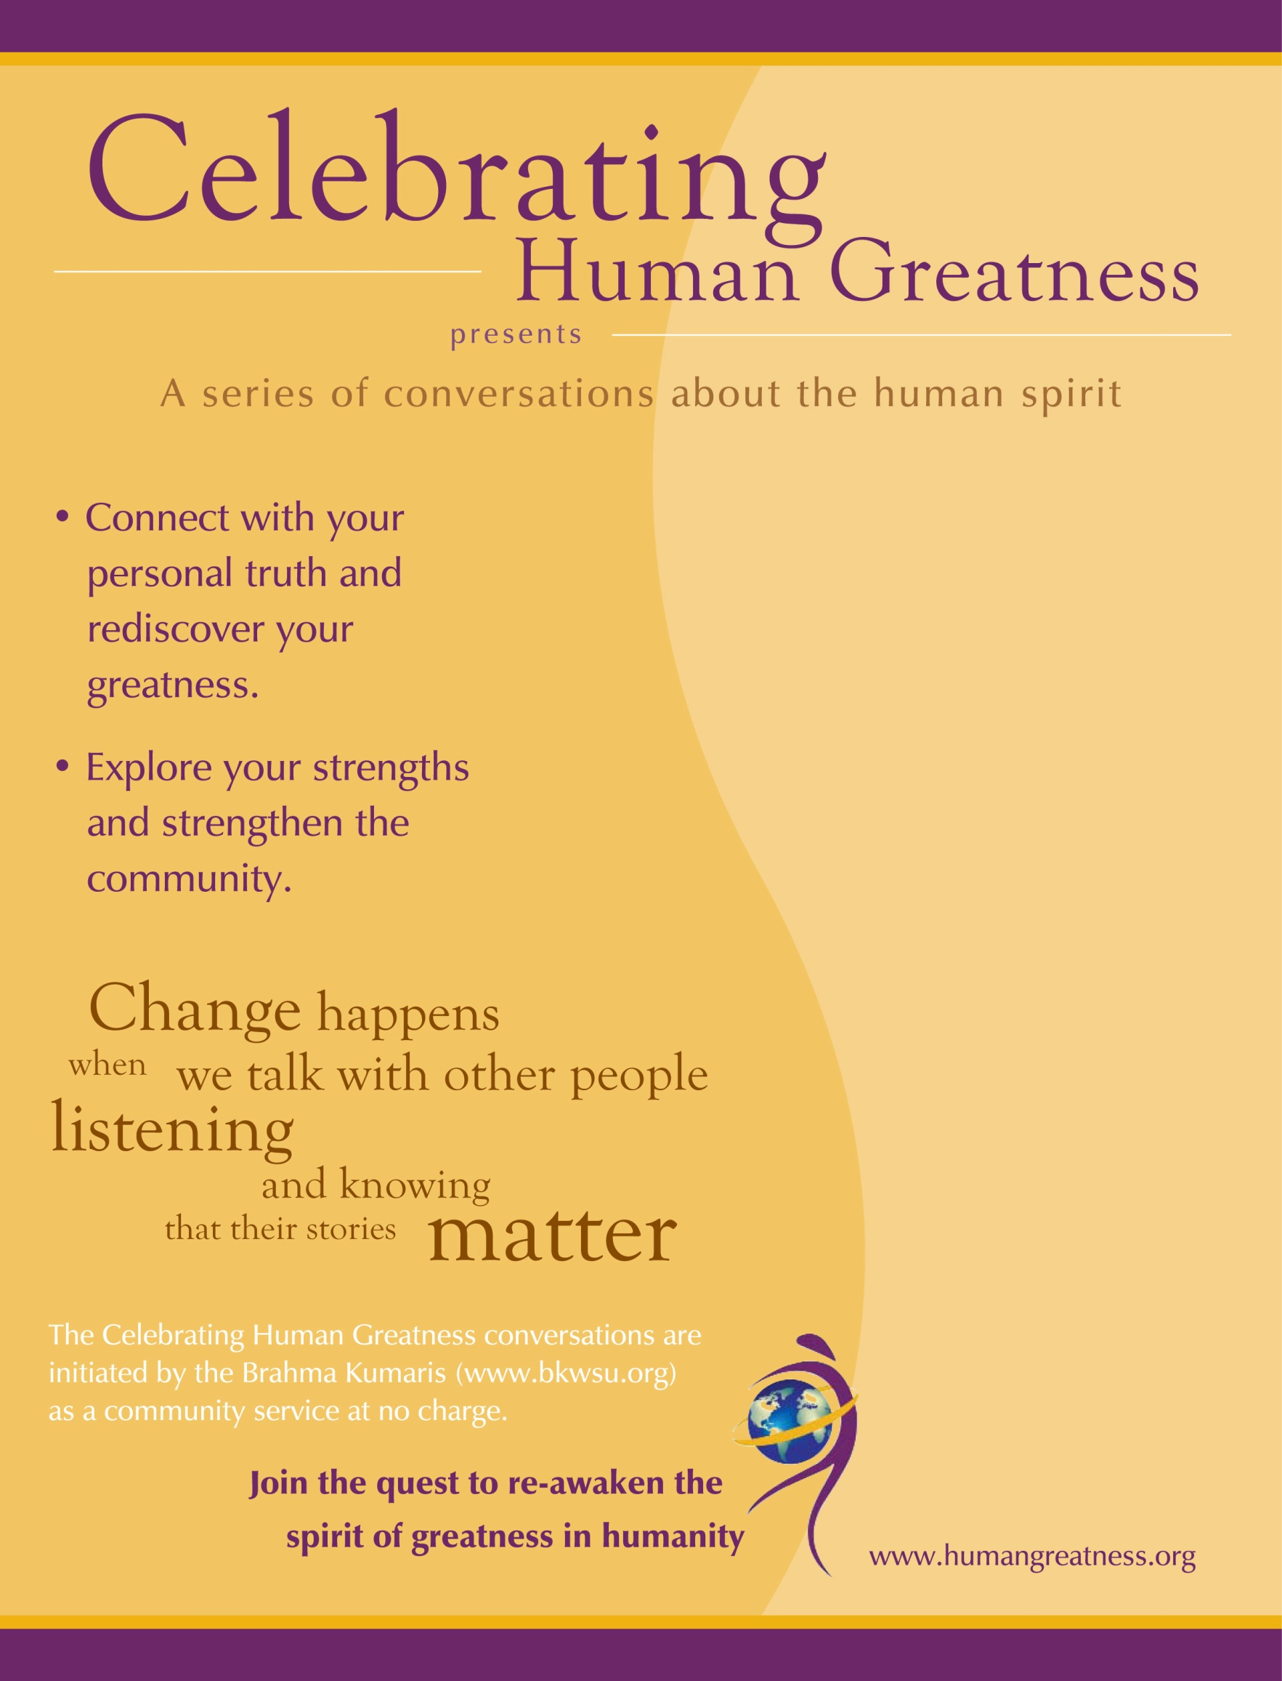
Join us in the month of June to explore and meditate together on:

Tuesdays from 7:00-8:30pm
June 2 - In God we Trust
June 9 - The Golden Rule
June 16 - The Inheritance of Spiritual Power
June 23 - Suddenly and Always Ready

Brahma Kumaris Meditation Center
1607 W De Leon Street
Tampa, FL 33606

For questions call 813-987-2525 or email tampasouth@us.bkwsu.org

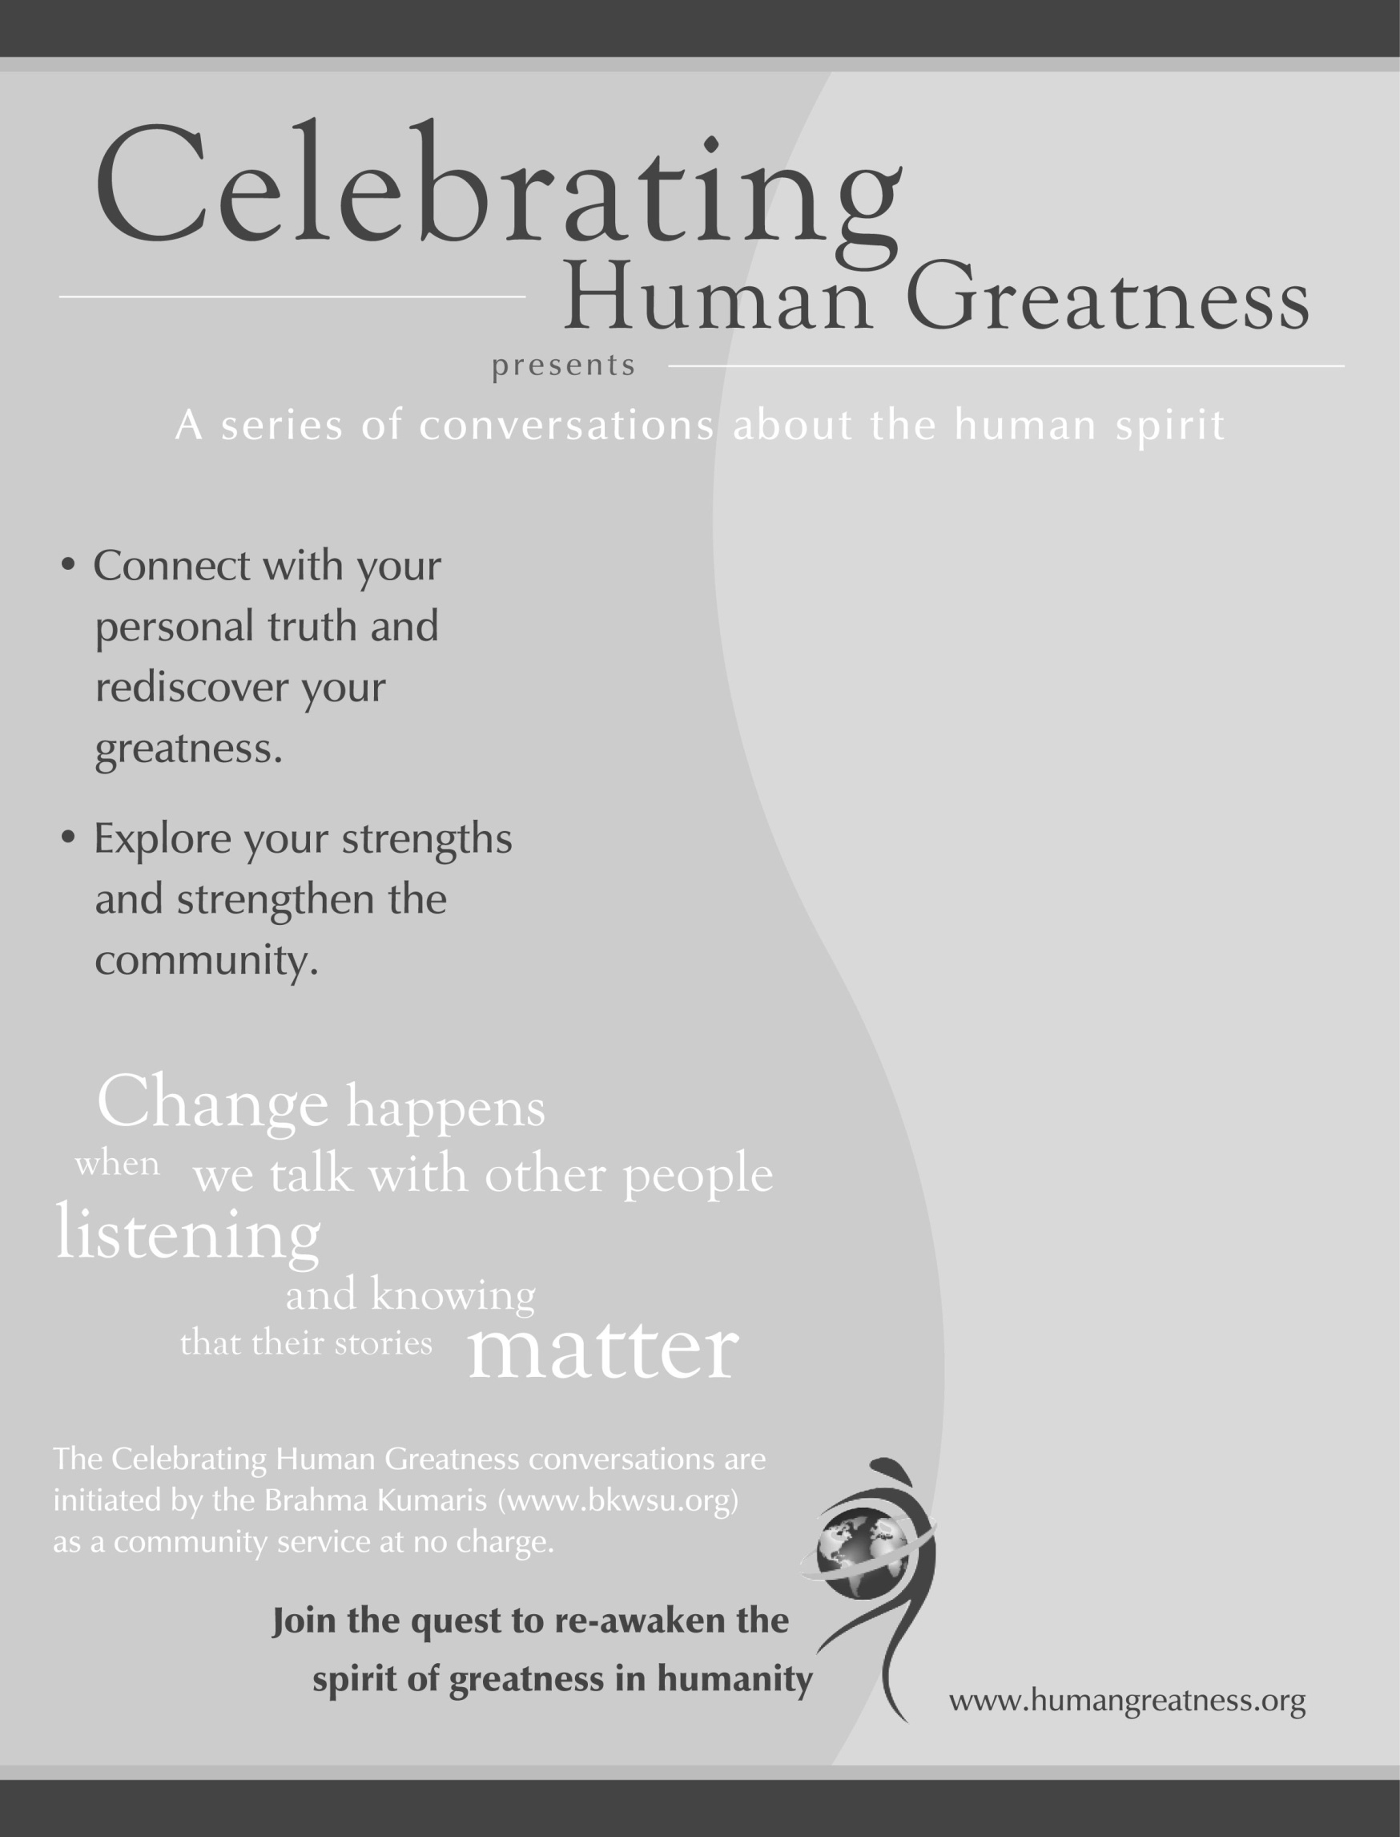
Join us in the month of June to explore and meditate together on:

Tuesdays from 7:00-8:30pm
June 2 - In God we Trust
June 9 - The Golden Rule
June 16 - The Inheritance of Spiritual Power
June 23 - Suddenly and Always Ready

Brahma Kumaris Meditation Center
1607 W De Leon Street
Tampa, FL 33606

For questions call 813-987-2525 or email tampasouth@us.bkwsu.org

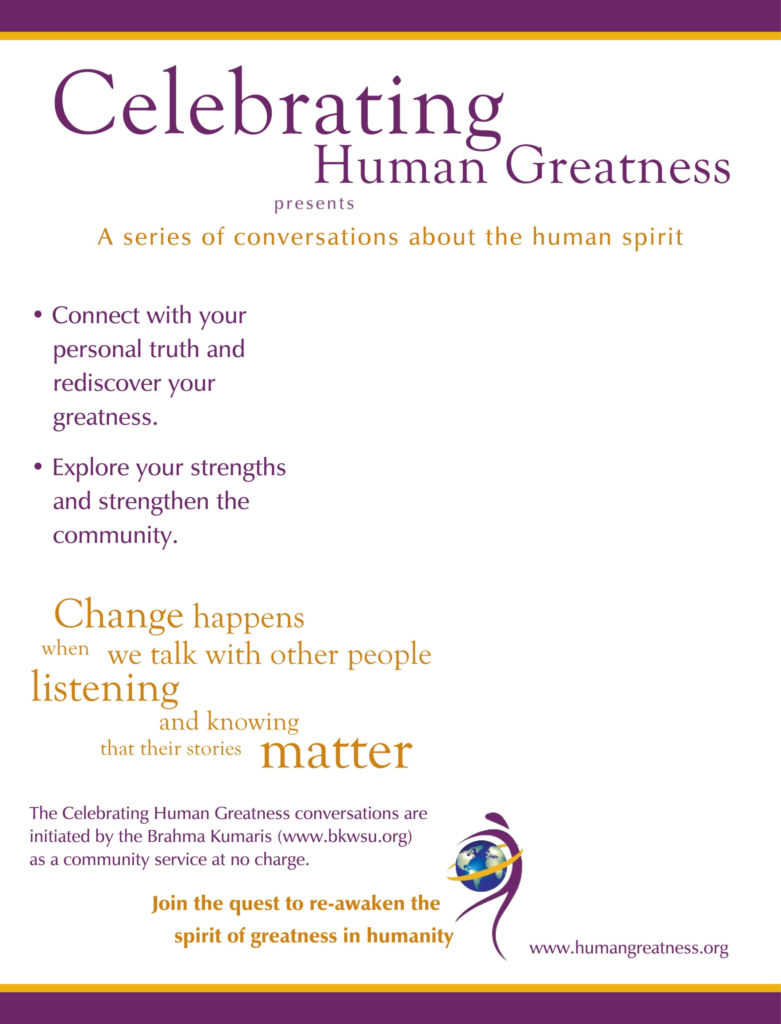
Join us in the month of June to explore and meditate together on:

Tuesdays from 7:00-8:30pm
June 2 - In God we Trust
June 9 - The Golden Rule
June 16 - The Inheritance of Spiritual Power
June 23 - Suddenly and Always Ready

Brahma Kumaris Meditation Center
1607 W De Leon Street
Tampa, FL 33606

For questions call 813-987-2525 or email tampasouth@us.bkwsu.org

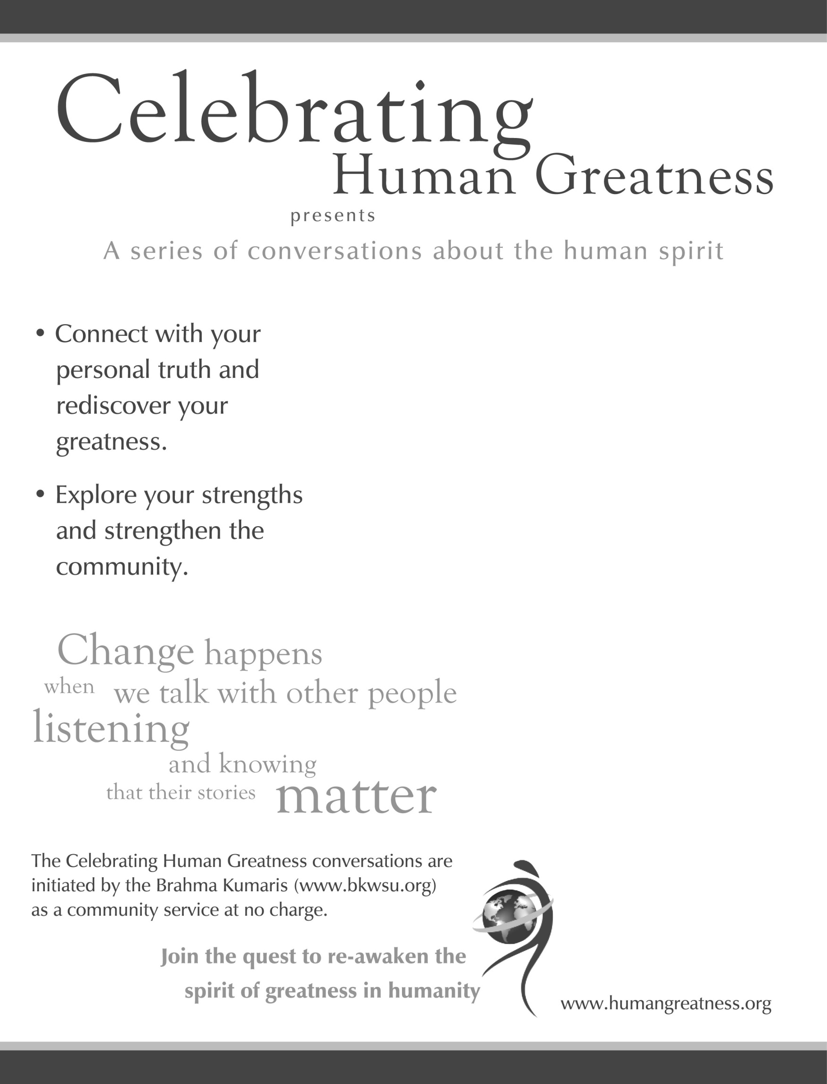
Join us in the month of June to explore and meditate together on:

Tuesdays from 7:00-8:30pm
June 2 - In God we Trust
June 9 - The Golden Rule
June 16 - The Inheritance of Spiritual Power
June 23 - Suddenly and Always Ready

Brahma Kumaris Meditation Center
1607 W De Leon Street
Tampa, FL 33606

For questions call 813-987-2525 or email tampasouth@us.bkwsu.org

