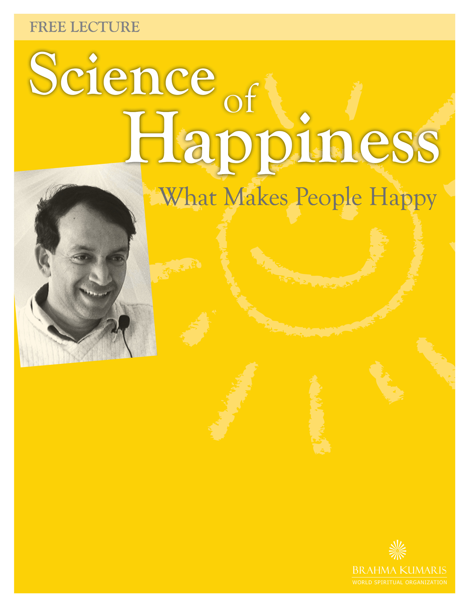
Studies in Positive psychology give us beautiful insights into what makes us happy. Surprisingly, observations show that what makes us happy is often contrary to our commonly held beliefs about happiness. The talk and the follow-up events are aimed to explore scientific and spiritual insights to the path of Happiness.

A surgeon by profession, Dr Kakoday’s main interests are in consciousness, the mind and the benefits of meditation. He has conducted research on attitudes, emotions, stress and health. He has spoken at various national and international health conferences and has given talks and programs in more than 60 countries.
Dr Kakody is an experienced student and teacher with the Brahma Kumaris World Spiritual Organization.
Friday, September 24 | 6:00-7:30pm
Creekside Community Centre | Olympic Village, False Creek
#1 Athletes Way, Vancouver, BC

For more information: (604) 436-4795
bkevents.vancouver @gmail.com | www.bkwsu.org/canada

