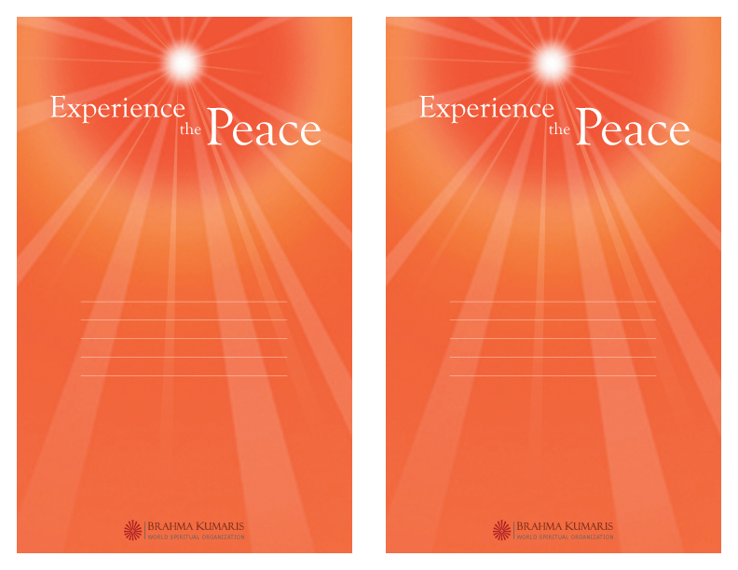
You are invited to visit and enjoy The Meditation Center and Gallery, located in the heart of Manhattan.
The Meditation Center is a reflective environment, a place to detach from the daily pressures of life and to explore spiritual principles, innate values, and one’s higher purpose.
Free courses, activities, and programs include:
Raja Yoga Meditation Course (ongoing classes)
Wisdom in Action (every Thursday at 6:30pm)
Secrets of Self-Esteem
Positive Thinking
Stress-Free Living
Anger Management
Registration is required.
The Meditation Center and Gallery
306 Fifth Avenue, 2nd Floor
(between 31st and 32nd Streets)
New York, NY 10001
Tel: 212-564-4335
email: manhattan@us.bkwsu.org
You are invited to visit and enjoy The Meditation Center and Gallery, located in the heart of Manhattan.
The Meditation Center is a reflective environment, a place to detach from the daily pressures of life and to explore spiritual principles, innate values, and one’s higher purpose.
Free courses, activities, and programs include:
Raja Yoga Meditation Course (ongoing classes)
Wisdom in Action (every Thursday at 6:30pm)
Secrets of Self-Esteem
Positive Thinking
Stress-Free Living
Anger Management
Registration is required.
The Meditation Center and Gallery
306 Fifth Avenue, 2nd Floor
(between 31st and 32nd Streets)
New York, NY 10001
Tel: 212-564-4335
email: manhattan@us.bkwsu.org

